# Graduation Statistics Report

This report provides an analysis of the graduation statistics from Future University across multiple academic years. The data covers male and female graduates and the total number of graduates from 2013-2014 to 2023-2024.

## Graduation Trends Chart

The following chart illustrates the trend of graduates over the years, highlighting the number of male, female, and total graduates.

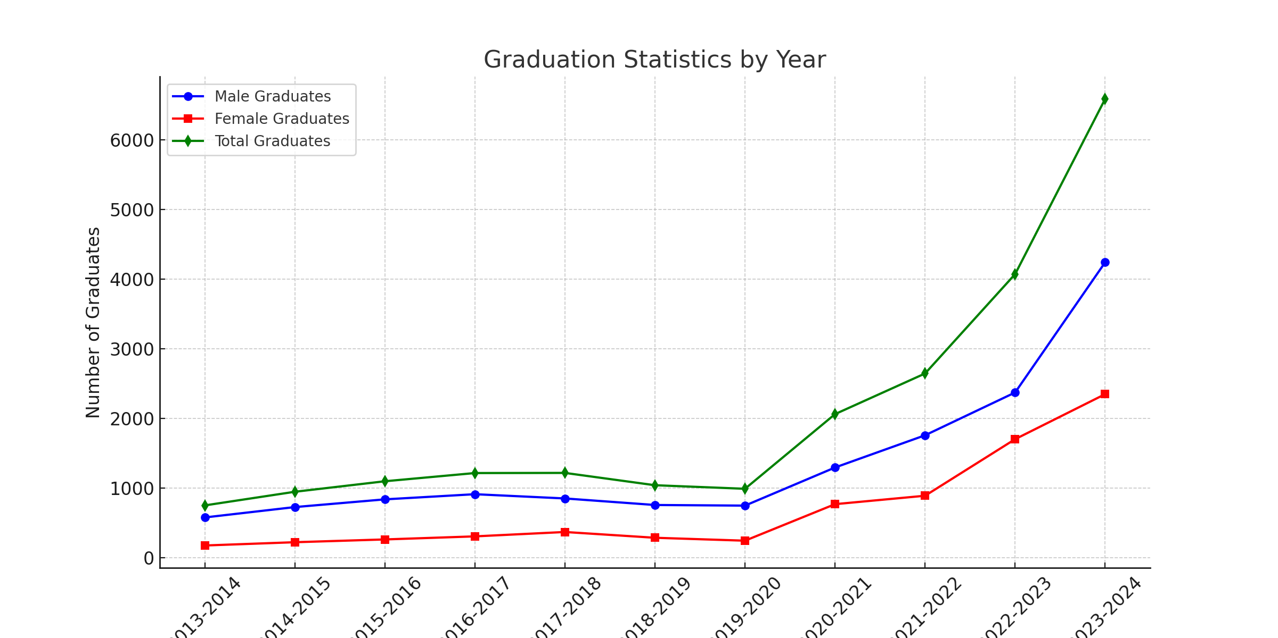

## Data Analysis

### 1. Growth in Graduate Numbers

The number of graduates has been steadily increasing over the years. In 2013-2014, there were 749 graduates, and by 2023-2024, this number had grown to 6,591. This indicates a significant expansion in student enrollment and graduation rates.

### 2. Male vs. Female Graduates

Throughout the years, male graduates have outnumbered female graduates. However, there has been a noticeable rise in female graduates, particularly in recent years. In 2013-2014, there were 576 male graduates and 173 female graduates, whereas in 2023-2024, the numbers had risen to 4,243 males and 2,348 females.

### 3. Significant Growth Periods

Some academic years have witnessed a sharp rise in the number of graduates. Between 2019-2020 and 2020-2021, graduates increased from 988 to 2,061. Similarly, between 2022-2023 and 2023-2024, the numbers jumped from 4,073 to 6,591. These surges might be due to the expansion of academic programs and higher student intake.

## Conclusions and Recommendations

1. **Steady Growth**: The university has experienced consistent growth in graduate numbers, which indicates a healthy academic environment.  
2. **Rising Female Participation**: The number of female graduates has increased significantly, which reflects the improved access to higher education for women.  
3. **Understanding Growth Surges**: It is essential to analyze the reasons behind the rapid increase in graduates in certain years to ensure sustainable growth.  
4. **Enhancing Academic Support**: With increasing student numbers, maintaining high educational standards and student support services is crucial.